### **Welcome to third grade! We look forward to learning and growing along with our new third grade students!**

### **Third graders will have the opportunity to have 1:1 technology this year! This means each child will have their own laptop to use during the school day. We are looking forward to the opportunity to use this tool to benefit your child’s education.**

**A supply list for your child is below. Please reference the picture of the pencil box with the supplies already unwrapped and ready to go on the first day. Please only send the supplies shown in the pencil box. Save extra supplies, at home, until your child needs replenishment. Thank you in advance for your help with these items!**

* **Backpack to carry items to and from school.**
* **Refillable water bottle with your child’s name clearly labeled (sport tops preferred).**
* **Earbuds/headphones with container or case (please label these items with your child’s name and keep in mind space is limited).**
* **A class fee of $25. Checks are greatly appreciated and should be made out to Spanish Springs Elementary School. The funds will be used for various art projects and other supplies throughout the year.**
* **1 Pencil box (PLASTIC ONLY) with the following supplies unwrapped and already inside:**

**-2 glue sticks**

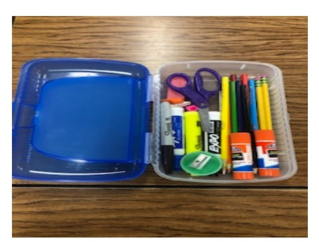**-5 pencils**

**-1 pair of blunt scissors**

**-1 pink eraser**

**-5 pencil top erasers**

**-1 hand-held pencil sharpener**

**-1 package of colored pencils (no more than 12 colors)**

**-2 black Sharpies-ultra fine point**

**-2 black Sharpies-fine point**

**-1 highlighter-any color**

**-2 Expo markers**

* **2 wide-ruled COMPOSITION notebooks (NO SPRIAL PLEASE)**
* **1 1-INCH 3-ring binder with pockets on the bottom (NO ZIPPERS PLEASE)**
* **1 pack of 5 dividers to go in the 1-inch binder**
* **2 pocket folders with pockets on the bottom (NO PRONGS)**
* **1 box of tissues**

**We look forward to a safe and successful third grade year!**

**Mrs. Allen, Mrs. Kindred and Mrs. McMillan**

[This Photo](http://www.3rdgradethoughts.com/2012/10/whole-brain-teaching-switching-up-class.html) by Unknown Author is licensed under [CC BY-ND](https://creativecommons.org/licenses/by-nd/3.0/)



[This Photo](http://www.3rdgradethoughts.com/2012/10/whole-brain-teaching-switching-up-class.html) by Unknown Author is licensed under [CC BY-ND](https://creativecommons.org/licenses/by-nd/3.0/)